HttpErrorStatus Code:

Contents

***What are status codes HTTP?*** 1

***Code:*** 1

POST Request: 3

Success: 200 http://localhost:3000/ilove/cricket/soumya 3

Error:400 http://localhost:3000/ilove/cricket/soumy 3

GET Request: 4

Success :200 4

Error:404 4

**How to download and run Postman?** 5

# ***What are status codes HTTP?***

*An HTTP status code is****a server response to a browser's request****. When you visit a website, your browser sends a request to the site's server, and the server then responds to the browser's request with a three-digit code: the HTTP status code.*

*200-success*

*400-Bad Request*

*401-Un authorized*

*404-Not found*

*500-Internal server error*

*502- Bad gateway*

*Follow for more details:* [*https://en.wikipedia.org/wiki/List_of_HTTP_status_codes*](https://en.wikipedia.org/wiki/List_of_HTTP_status_codes)

# ***Code:***

const express = require('express')// Express module just as you require other modules and puts it in a variable. var app = express(); => Calls the express function "express()" and puts new Express application inside the app variable (to start a new Express application)

const app = express();//create instance of express

const port = 3000 // server will run on this port (You can change the port number )

//NB: same port number you can't run different node project at the same time.

//*********HTTP STATUS CODE***************** http://localhost:3000/ilove/cricket/soumya

var dataStore=[]

app.post('/ilove/:play/:name', function(req, res) {

    var choice = req.params.play;

    var name = req.params.name;

    if (name=='soumya'){ // check  the name is matching or not

    dataStore.push({choice: choice,name: name});

    var responseObject = { message: 'Hey ' + name +  ' i love ' + ' '+ choice + '  too! ' }; //concatination

    res.send(responseObject);

    }

    else{

        res.status(400).send();//when you post the data if its matching the name with soumya then data will be post with success 200 status code otherwise it will show 400 err status code.

    }

});

app.get('/iloves',function(req, res){

    if (dataStore.length==0){  // if dataStore is empty then it will show 404 http error status code

        res.status(404).send()

    }else{

        res.send(dataStore); // if any value is present inside the dataStore then it will show 200 success message.

    }

})

app.listen(port, () => {

  console.log(`Example app listening on port ${port}`)

})

# POST Request:

## Success: 200 http://localhost:3000/ilove/cricket/soumya

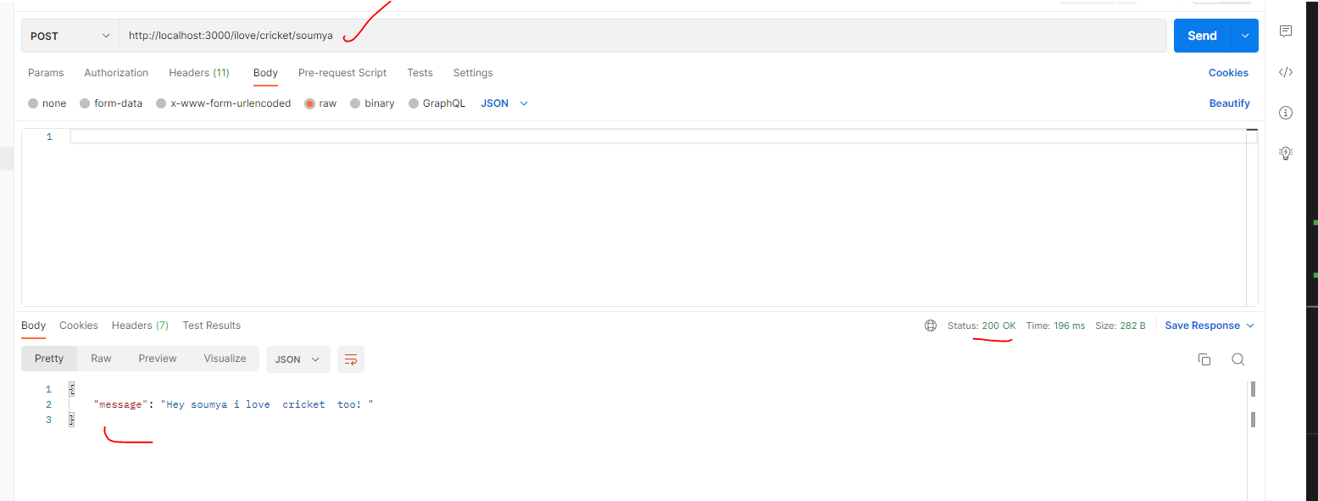

## Error:400 http://localhost:3000/ilove/cricket/soumy

*Error comes because mismatch with name compare with above image*

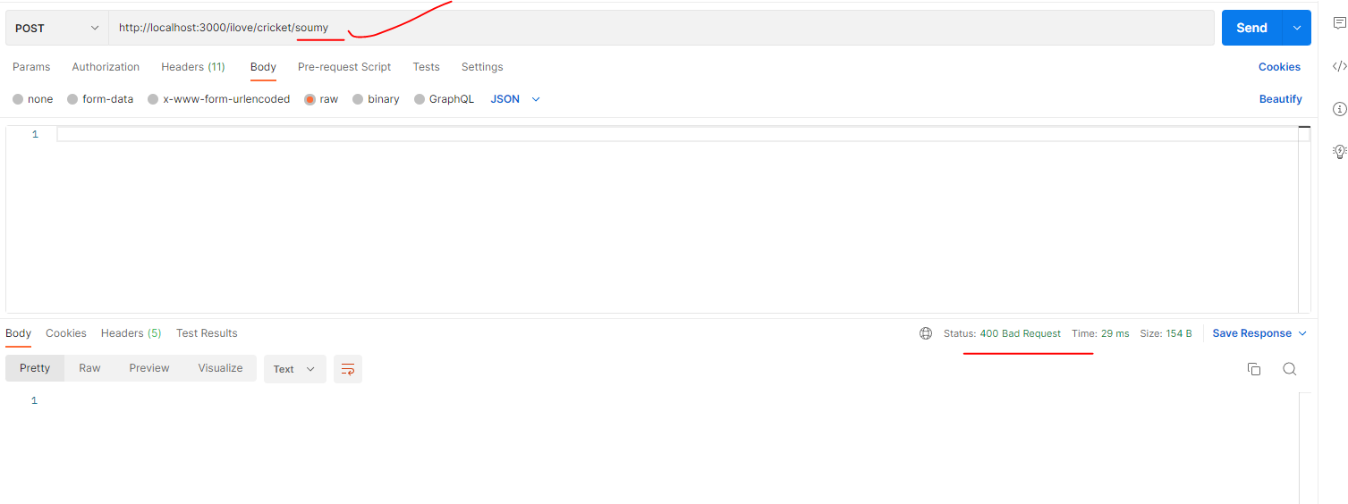

# GET Request:

## Success :200

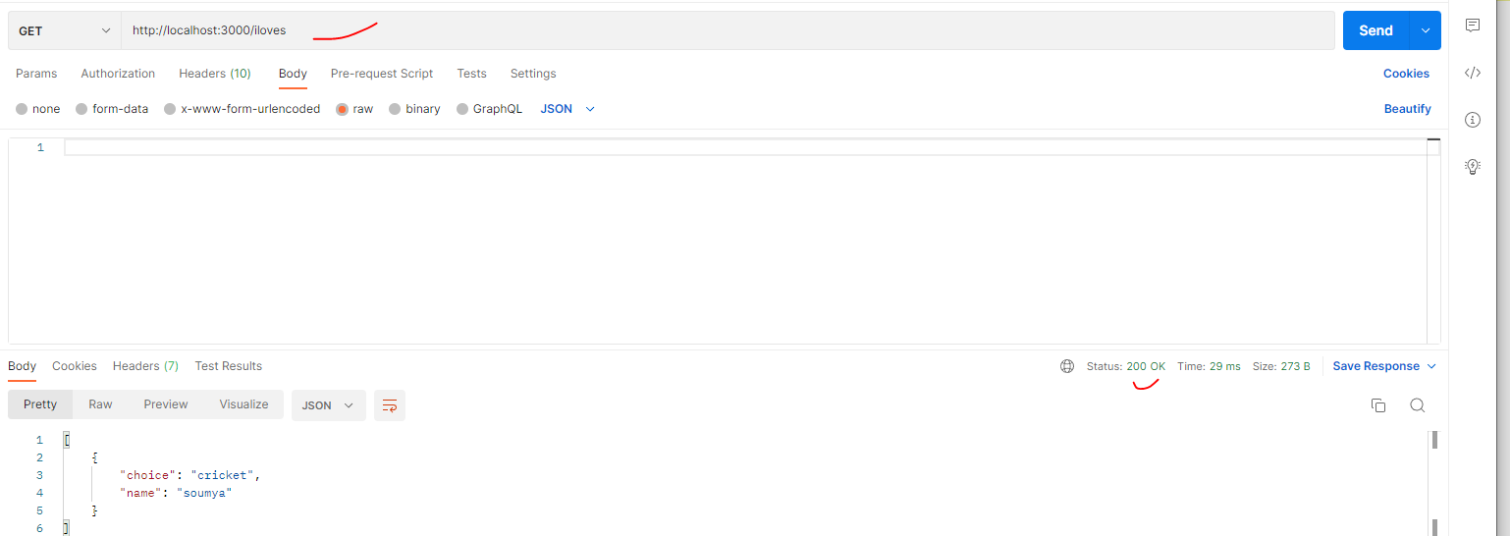

## Error:404

When [] is blank it will show this error status code. Check the code

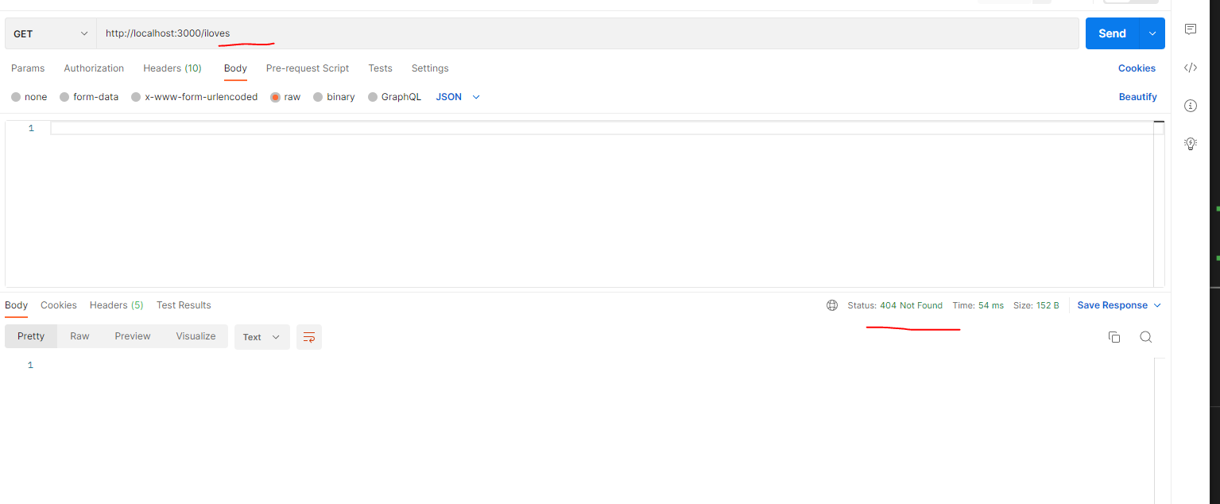

**How to download and run Postman?** Follow this video and do the same

<https://www.youtube.com/watch?v=3eHJkcA8mTs>

Download here: <https://www.postman.com/downloads/>

